SQL: DDL(Data Defination language )
- Commands : select||insert||update||delete
- Aggregate function
- Text func
- Datetime func
- Logic func
- Sub query
- Where
- Group by: having,limit,offset
- order

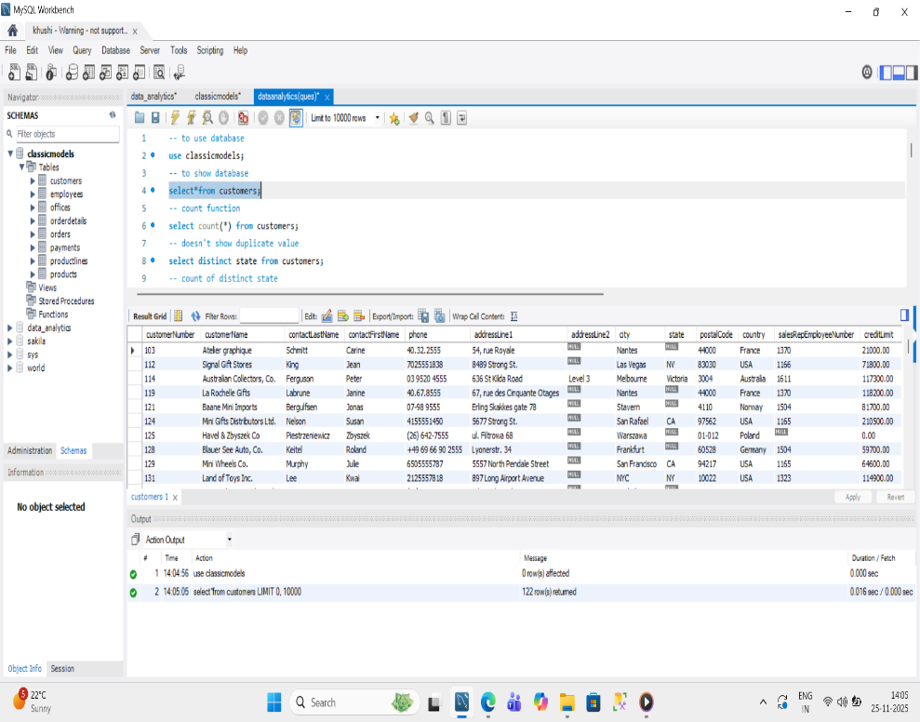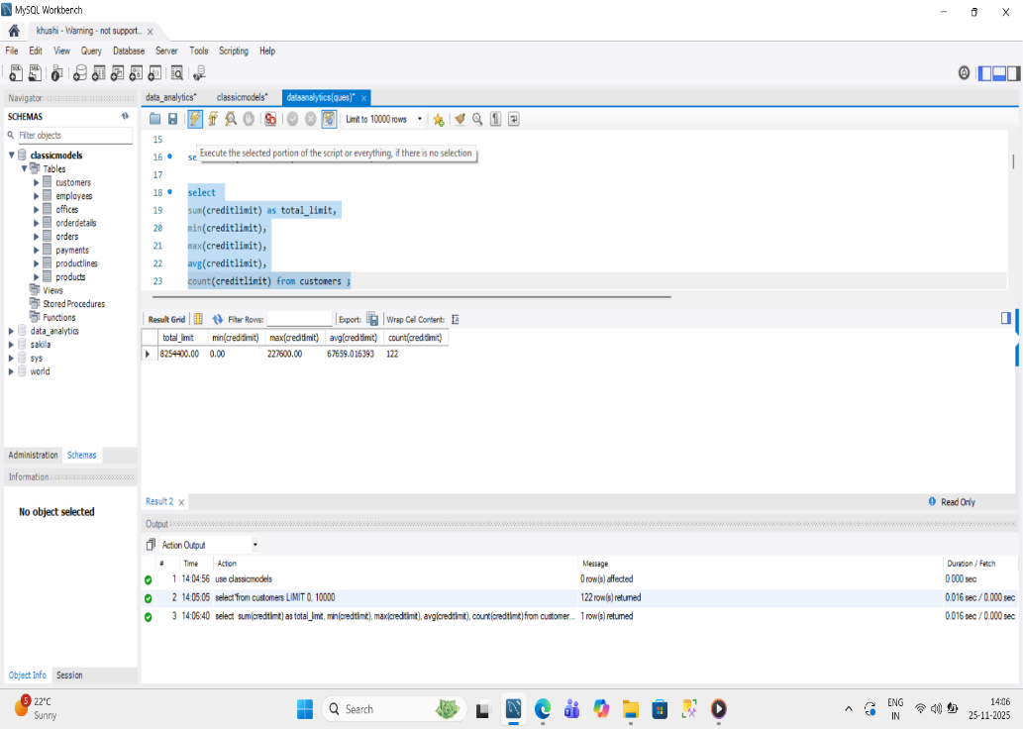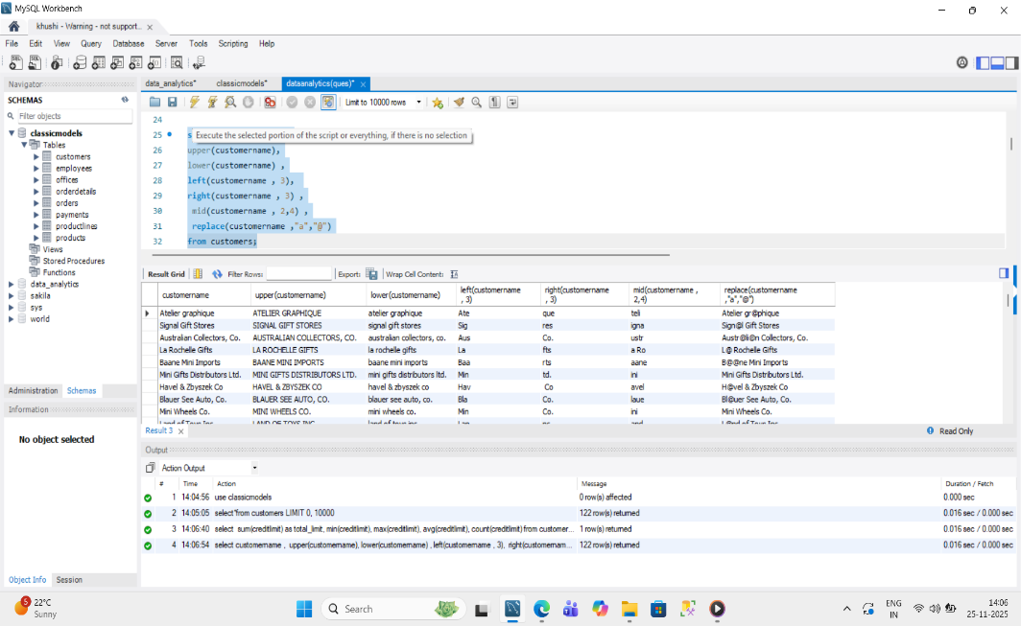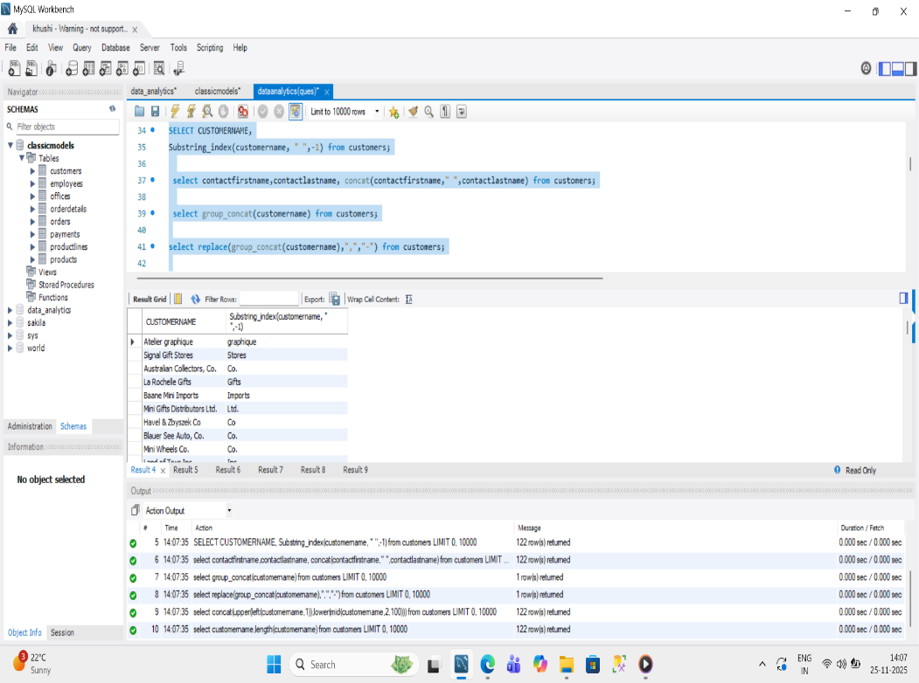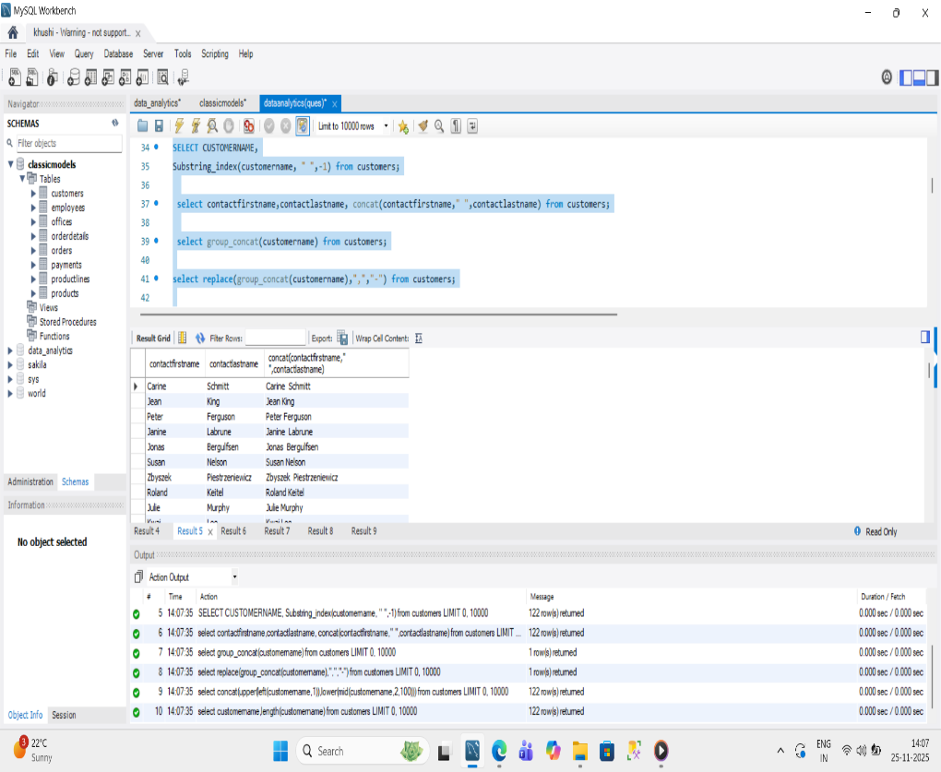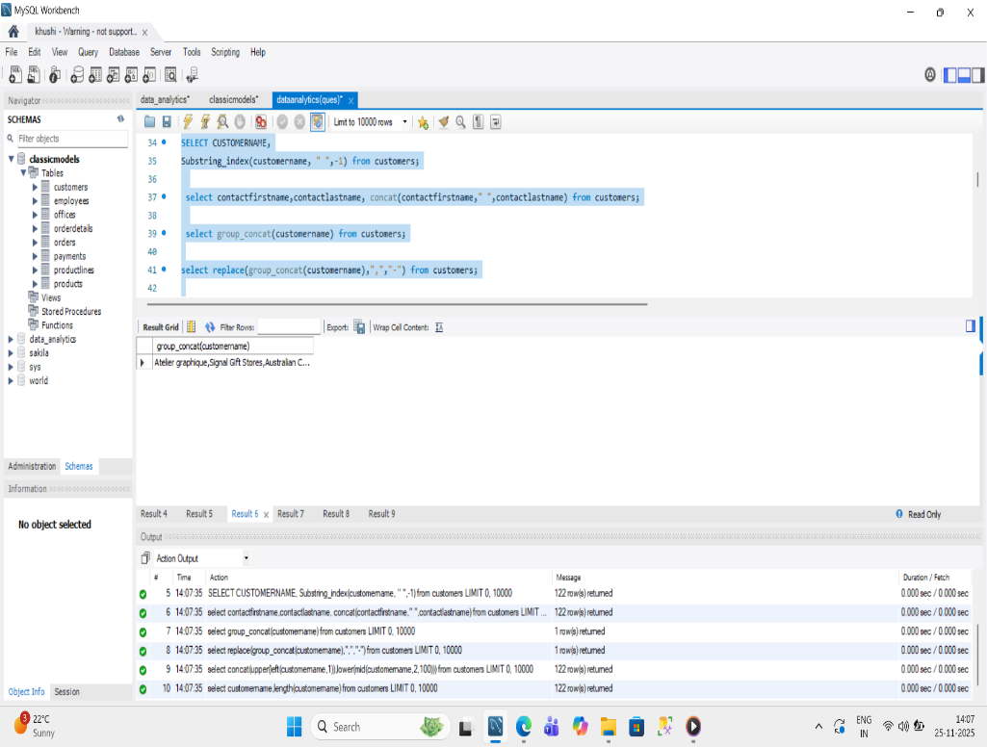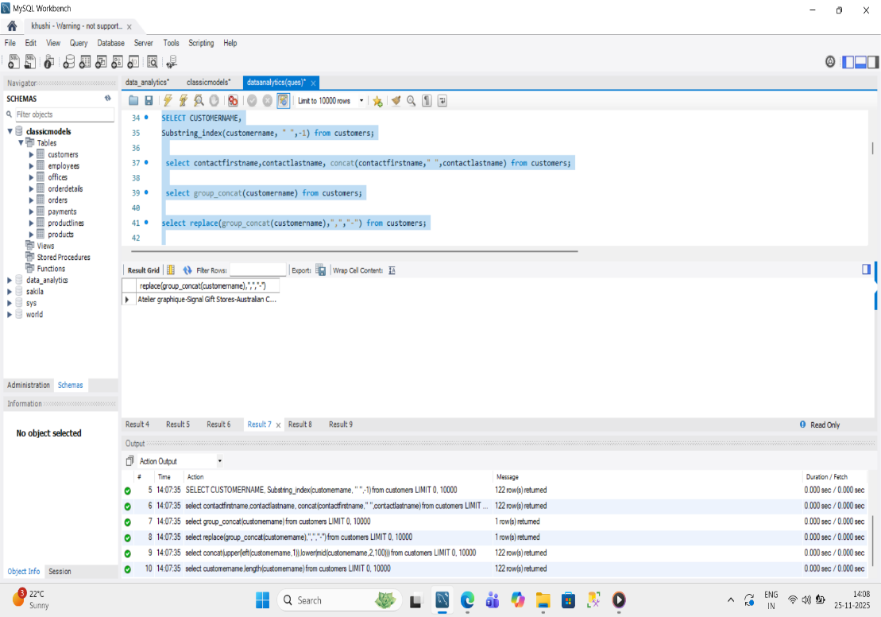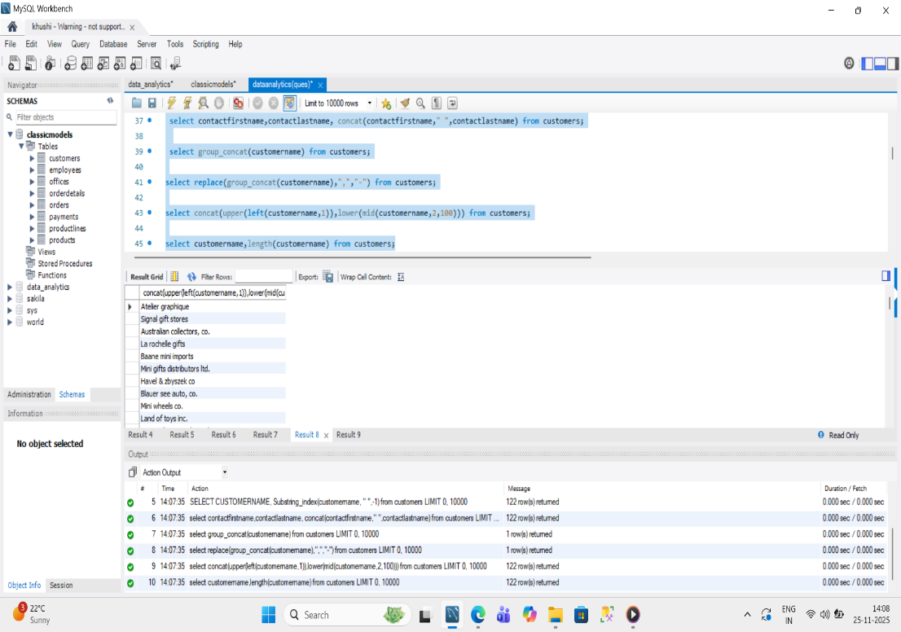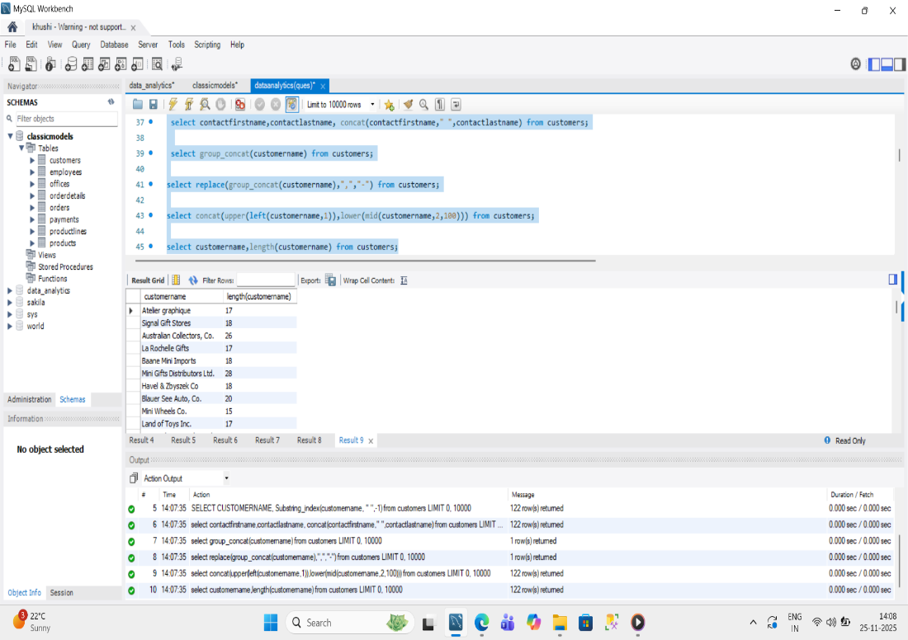:
Aggregate function
- Sum
- Max
- Min
- Avg
- Count
- Round
- Floor
- Ceil
- Truncate

To show database
Text function:
- Upper
- Lower
- Right
- Left
- Mid
- replace

1.
2.
3.
4.
5.
6.

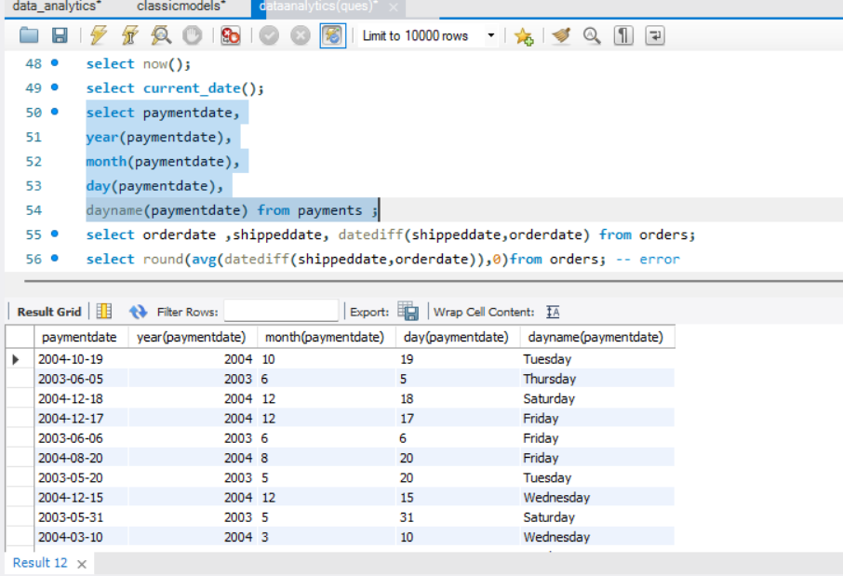
Datetime function

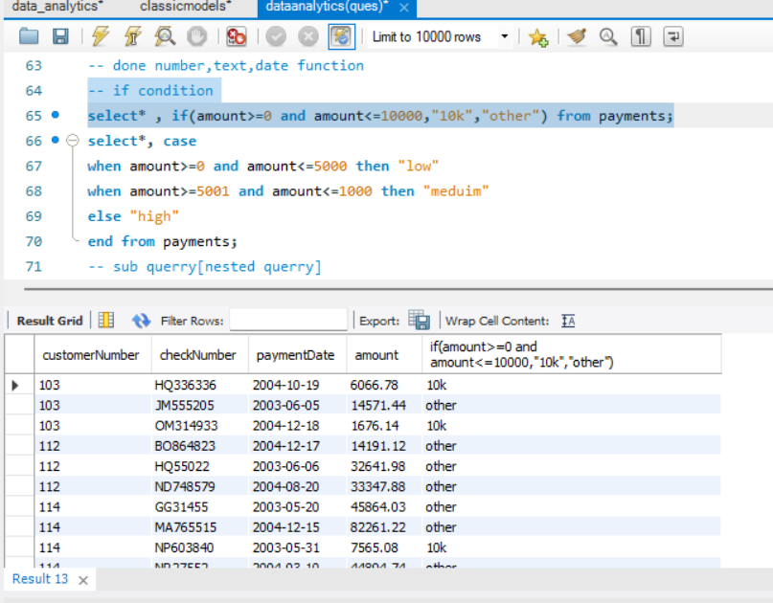
If condition

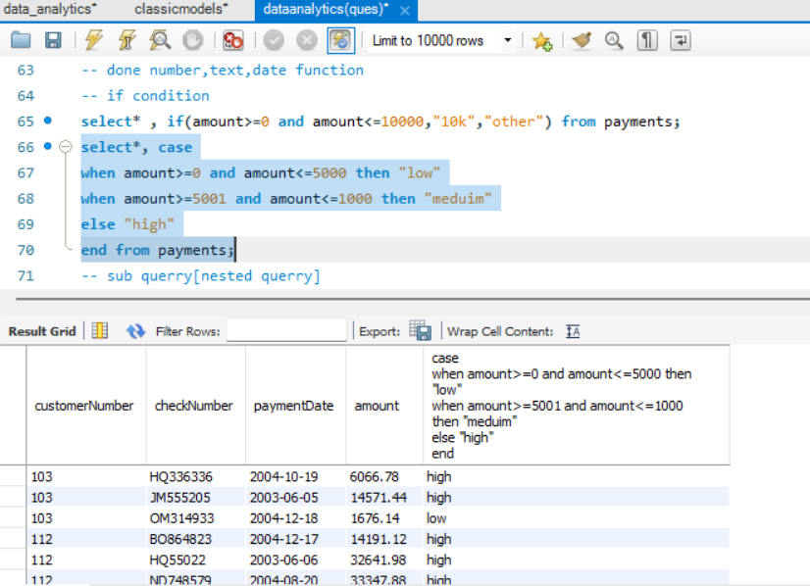
Case else

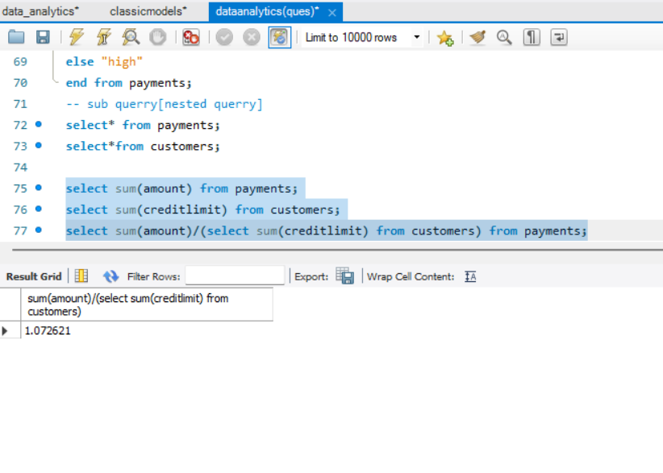
Sub query

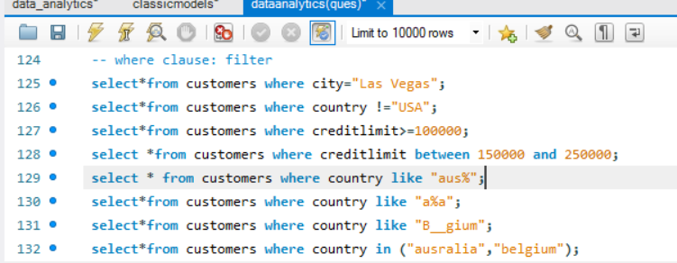
Where clause
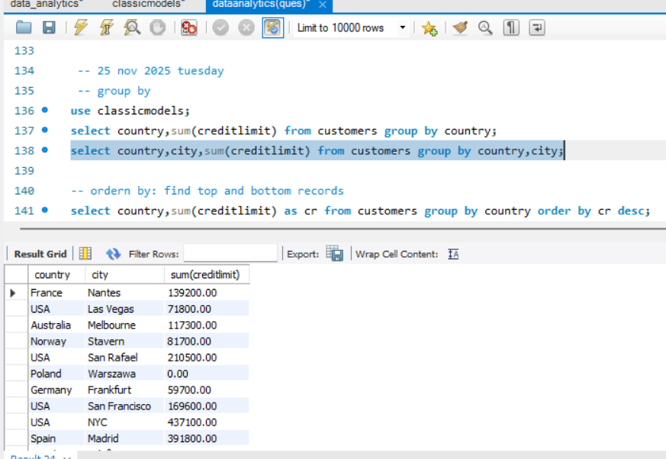
Group by
Order by:
Sequence:
- Select
- Column,func
- Table name
- Where
- Group by
- Having
- Limit
- Offset

